1. Mockup for desktop - <https://xd.adobe.com/view/7243fb5b-c120-4955-a0ef-165267e8e81c-2710/screen/97d5295c-39b3-4cdb-8ec4-8d4ce307673b/?fullscreen>
2. Mockup for Mobile – I will attach screen shots can you can find in assignment 5 folder
3. Icons – Font awesome icons
4. Use bootstrap for styling
5. Colors

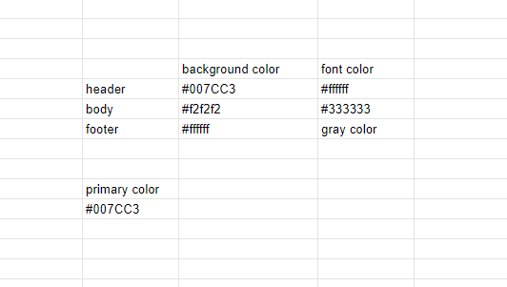

1. If u need any extra colors not mentioned above use color picker and get the color code
2. Browser compatibility – IE11, Chrome, Microsoft Edge

**Assets:**

Hero banner section video - [The All-New Scorpio-N has arrived](https://youtu.be/NqOEx0bJDLw)

[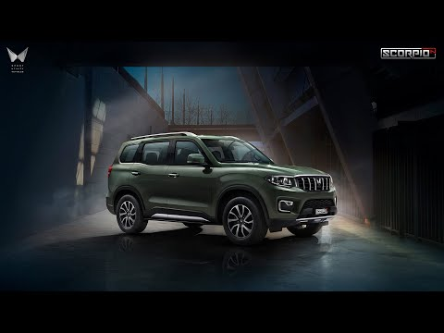](https://youtu.be/NqOEx0bJDLw)

Image on right side: <https://service.secureoffersites.com/images/GetEvoxImage?styleid=404121&Width=900&Angle=116&type=png&crop=true&useoverrides=True>

Header logo: mobile and desktop

<https://service.secureoffersites.com/images/GetLibraryImage?fileNameOrId=87318&Width=0&Height=0&quality=85>